Measurement

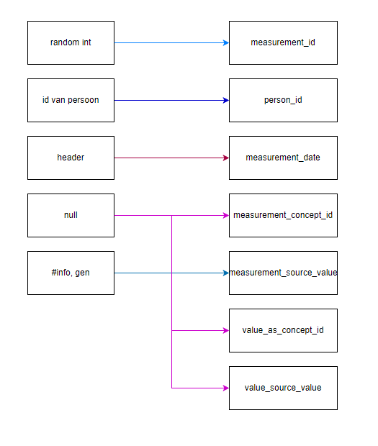

| Destination field | Source field | Logic | Comments |
| --- | --- | --- | --- |
| measurement_id | random int |  |  |
| person_id | id van person | Dit zal gewoon een waarde van 1 t/m3 zijn gegeven aan de patient |  |
| measurement_date | header |  |  |
| measurement_concept_id | Null |  |  |
| measurement_source_value | #info, gen |  |  |
| value_as_concept_id | null |  |  |
| value_source_value | null |  |  |